**AS3 Project Design Document**

Jazz Malone 9103199616

**Table of Contents**

Contents

Overview: 3

Purpose: 3

Create Use case diagrams: 3

Create Class diagrams: 3

Database Logical Design: 4

Identify project entities: 5

Establish entity-relationships: 5

Complete E-R diagram (to 3NF): 5

Complete table data structures/ List table columns/attributes : 6

Identify primary and foreign keys: 7

Create test data: 7

Complete TOE charts/ Complete GUI design: 9

Sign Off: 15

# Overview:

This document will present and outline certain procedures and design elements the project will require while being undertaken. Some of the points presented will be database structure and design, project entities and their relationships and GUI planning and design.

# Purpose:

The purpose of this document is to provide a look as to what we believe is the best way to structure and design this project.

# Create Use case diagrams:

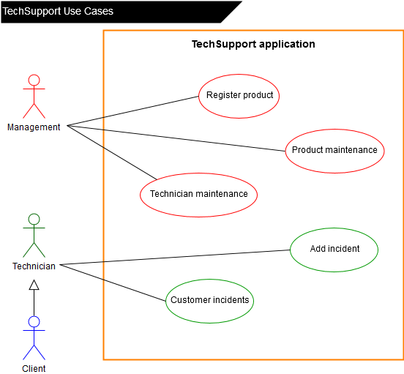

# Create Class diagrams:

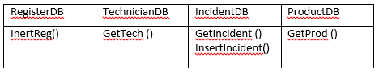

# Database Logical Design:

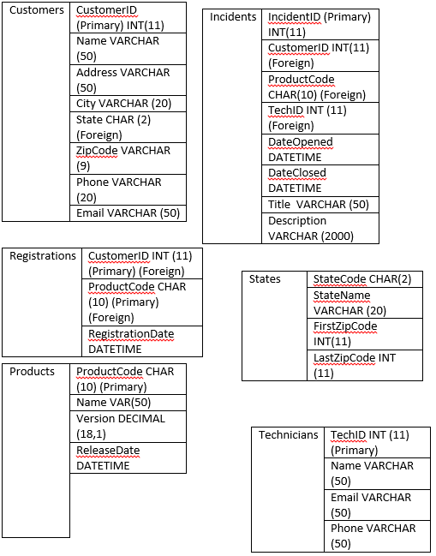

# Identify project entities

Customer, Incidents, Technicians, Products.

# Establish entity-relationships

# Complete E-R diagram (to 3NF)

# Complete table data structures/ List table columns/attributes

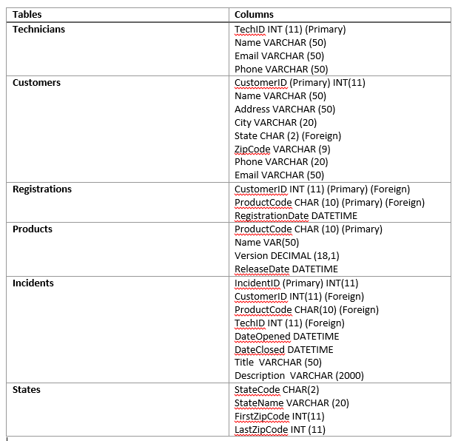

# Identify primary and foreign keys:

**Customers:**

Primary: CustomerID

Foreign: StateCode

**Incidents:**

Primary: IncidentID

Foreign: CustomerID, ProductCode, TechID

**Products:**

Primary: ProductCode

Foreign: N/A

**Registrations:**

Primary: CustomerID, ProductCode

Foreign: CustomerID, ProductCode

**States:**

Primary: StateCode

Foreign: N/A

**Technicians:**

Primary: TechID

Foreign: N/A

# Create test data:

|  |  |  |  |  |  |  |  |
| --- | --- | --- | --- | --- | --- | --- | --- |
| Customers | | | | | | | |
| CustomerID | Name | Address | City | State | ZipCode | Phone | Email |
| 1 | Test | 1 Test Road | Testville | TE | 1234 | 0412345678 | test@test.com |
| 2 | John | 2 Test Drive | Testton | TY | 2468 | 0424681012 | john@test.com |

|  |  |  |  |
| --- | --- | --- | --- |
| States | | | |
| StateCode | StateName | FirstZipCode | LastZipCode |
| TE | Test | 1000 | 2000 |
| TY | Testy | 2000 | 3000 |

|  |  |  |  |  |  |
| --- | --- | --- | --- | --- | --- |
| Incidents | | | | | |
| IncidentID | CustomerID | ProductCode | TechID | DateOpened | DateClosed |
| 1 | 2 | GMS20 | 2 | 12/12/2017 | 20/12/2017 |
| 2 | 2 | GMS20 | 2 | 5/5/2018 | 10/5/2018 |
| Title | | | Description | | |
| Program crashes when loading project | | | Program hangs when large project is opened. | | |
| CPU usage overload | | | Program eats up CPU. | | |

|  |  |  |  |
| --- | --- | --- | --- |
| Products | | | |
| ProductCode | Name | Version | ReleaseDate |
| IPE153 | Infinity Photo Editor | 15.3 | 12/2/2018 |
| UAE925 | Unableton | 9.2.5 | 11/02/2016 |

|  |  |  |
| --- | --- | --- |
| Registrations | | |
| CustomerID | ProductCode | RegistrationsDate |
| 1 | IPE153 | 1/11/2017 |
| 2 | IPE153 | 02/09/2017 |

|  |  |  |  |
| --- | --- | --- | --- |
| Technicians | | | |
| TechID | Name | Email | Phone |
| 1 | John Smith | jsmith@tech.com | 051234913547 |
| 2 | Jane Doe | [jdoe@](mailto:MrHoot@aSite.com)tech.com | 591713975757 |

# Complete TOE charts/ Complete GUI design

|  |  |  |
| --- | --- | --- |
| **Index Screen** |  |  |
| **Task** | **Object** | **Event** |
| Display Customer Info | gridViewCustomers |  |
| Get Customer Data | SqlDataSourceTechSupport |  |

**Index of Customers**

|  |  |  |
| --- | --- | --- |
| **Product Maintenance** |  |  |
| **Task** | **Object** | **Event** |
| Display Products | gridViewProducts |  |
| Get Product Data | SqlDataSourceTechSupport |  |

**Product Maintenance**

|  |  |  |
| --- | --- | --- |
| **Add New Product** |  |  |
| **Task** | **Object** | **Event** |
| Adds New Product |  |  |
| Product Code | tbProduct |  |
| Product Name | tbCode |  |
| Version | tbVersion |  |
| Release Date | tbDate |  |
|  |  |  |
| Return to Previous Page | btnReturn | Click |
| Submit Product | btnSubmit | Click |

**Add New Product**

|  |  |  |
| --- | --- | --- |
| **Technician Maintenance** |  |  |
| **Task** | **Object** | **Event** |
| Displays Technicians | gridViewTechs |  |
| Get Tech Data | SqlDataSourceTechSupport |  |
|  |  |  |
| Go to New Add Tech | btnAddTech | Click |

**Technician Maintenance**

|  |  |  |
| --- | --- | --- |
| **Add New Technician** |  |  |
| **Task** | **Object** | **Event** |
| Add New Technician |  |  |
| Technician Name | tbName |  |
| Email | tbEmail |  |
| Phone Number | tbPhone |  |
|  |  |  |
| Return to Previous Page | btnReturn | Click |
| Submit Form | btnSubmit | Click |

**Add New Technician**

|  |  |  |
| --- | --- | --- |
| **Customer Registration** |  |  |
| **Task** | **Object** | **Event** |
| Adds New Customer |  |  |
| Customer Name | tbName |  |
| Address | tbAddress |  |
| City | tbCity |  |
| State | tbState |  |
| Zipcode | tbZipcode |  |
| Phone | tbPhone |  |
| Email | tbEmail |  |
|  |  |  |
| Return to Previous Page | btnReturn | Click |
| Submit form | btnSubmit | Click |

**Customer Registration (if necessary)**

|  |  |  |
| --- | --- | --- |
| **Incident** |  |  |
| **Task** | **Object** | **Event** |
| Select Incident |  |  |
| Dropdown List of Names | dropDownCustomers | Click |
| Customer ID | tbCustID |  |
| Search Customers by ID | btnSearch | Click |
| Customer Address | tbAddress |  |
| City | tbCity |  |
| State | tbState |  |
| Zipcode | tbZipcode |  |
| Phone | tbPhone |  |
| Email | tbEmail |  |
|  |  |  |
| Go to Add New Incident | btnAddIncident | Click |
|  |  |  |
| Display Selected Incident | gridViewIncidents | OnSelection |

**Incidents**

|  |  |  |
| --- | --- | --- |
| **Add New Incident** |  |  |
| **Task** | **Object** | **Event** |
| Create New Incident |  |  |
| Customer Name | dropDownCustomer | Click |
| Customer ID | tbCustID |  |
| Date Opened | tbDate |  |
| Product | dropDownProduct | Click |
| Description | tbDescription |  |
|  |  |  |
| Return to Previous | btnPrevious | Click |
| Submit Incident | btnSubmit | Click |

**Add New Incident**

|  |  |  |
| --- | --- | --- |
| **Manage Incident** |  |  |
| **Task** | **Object** | **Event** |
| Manage Selected Incident |  |  |
| Incident ID | tbIncID |  |
| Customer ID | tbCustID |  |
| Customer Name | tbName |  |
| Date Opened | tbDate |  |
| Product | tbProduct |  |
| Title | tbTitle |  |
| Description | tbDescription |  |
|  |  |  |
| Return To Previous | btnReturn | Click |
| Close Ticket | btnRemove | Click |
| Update Description | btnUpdate | Click |

**Manage Selected Incident**